**Instructions for Determining Eligibility Based on Census Data**

**Step 1: Become familiar with the census data format**

About the 2010 Census Block Group

Every 10 years, the Census updates the area-based measures such as census tracts, blocks and block groups. CACFP, SFSP, SSO, ASCP can use both census tracts and block groups to determine area eligibility.

01

001

020100

1

The ideal size of a CBG is around 1500 homes but vary by region and area characteristics. Contrary to the name, CBGs are not usually shaped like rectangles; rather they can take any shape. The graphic on the left shows the relationship of CBGs to other geographical areas and the components of the GEOID.

Every CBG in the country is numerated, meaning it has a unique number assigned to it. This number is called the GEOID.

What information is in the GEOID?

The GEOID contains 12 digits. Each position in the GEOID signifies a different level of geographical area. Every digit is important, even the first zero. This is important to remember when importing these data, because some programs drop the first zero. There is more information below about how to import the data correctly.

Here is an example of a GEOID from Autauga County, Alabama:

010010201001

* **STATE**:  The first 2-characters are the State code
* **COUNTY**:  The next 3-characters are the county code
* **TRACT**:  The next 6-characters are the census tract code
* **BLOCK GROUP:**  The last character is the census block group code

**Step 2: Determine eligibility**

Below are instructions for two options to determine eligibility. Contracting entities (CEs) may use either tool.

1. The FNS Map. This map includes an address search that will return eligibility information as well as other demographics. This map also includes zoom capabilities and map comparison for identifying areas of need.
2. The Food Research and Action Center (FRAC) Map. These tools provide another method of identifying eligibility. There is one map for CACFP and one for SFSP, SSO, and ASCP but either map may be used to determine eligibility for any programs.

**Step 2, Option 1: Determining eligibility using the FNS Area Eligibility Mapper**

Go to: <http://www.fns.usda.gov/areaeligibility>

1. To find by address, enter the address in the “Find address or place” box in the top right.
2. Zoom in and out of the map using the (+) and (-) signs, respectively.
3. In the resulting map, the red highlighted color indicates eligibility as noted in the map layer key.
4. A larger map is available by clicking “View Larger Map” at the bottom of the screen.

**Step 2, Option2: Determining eligibility using the 2014 FRAC Food Mapper**

1. Go to either FRAC map:
   1. CACFP <http://216.55.168.186/FairData/CACFP/map.asp?command=scope&map=0>
   2. SFSP, SSO, and ASCP <http://216.55.168.186/FairData/SummerFood/map.asp?command=scope&map=0>
2. To find by address, click on “Find” and enter the address.
3. In the resulting map, the highlighted color indicates eligibility as indicated in the map layer key.
4. 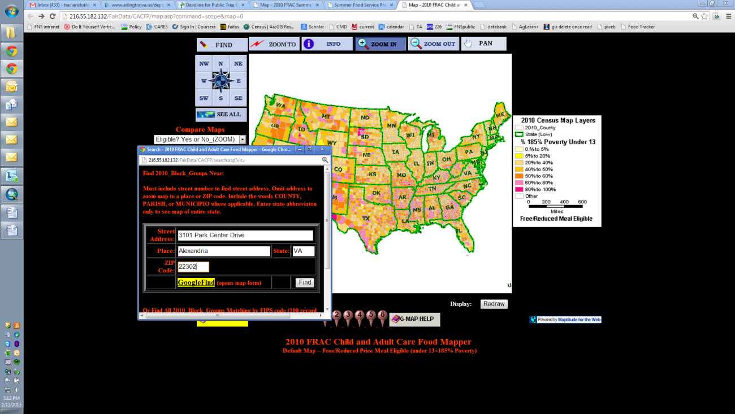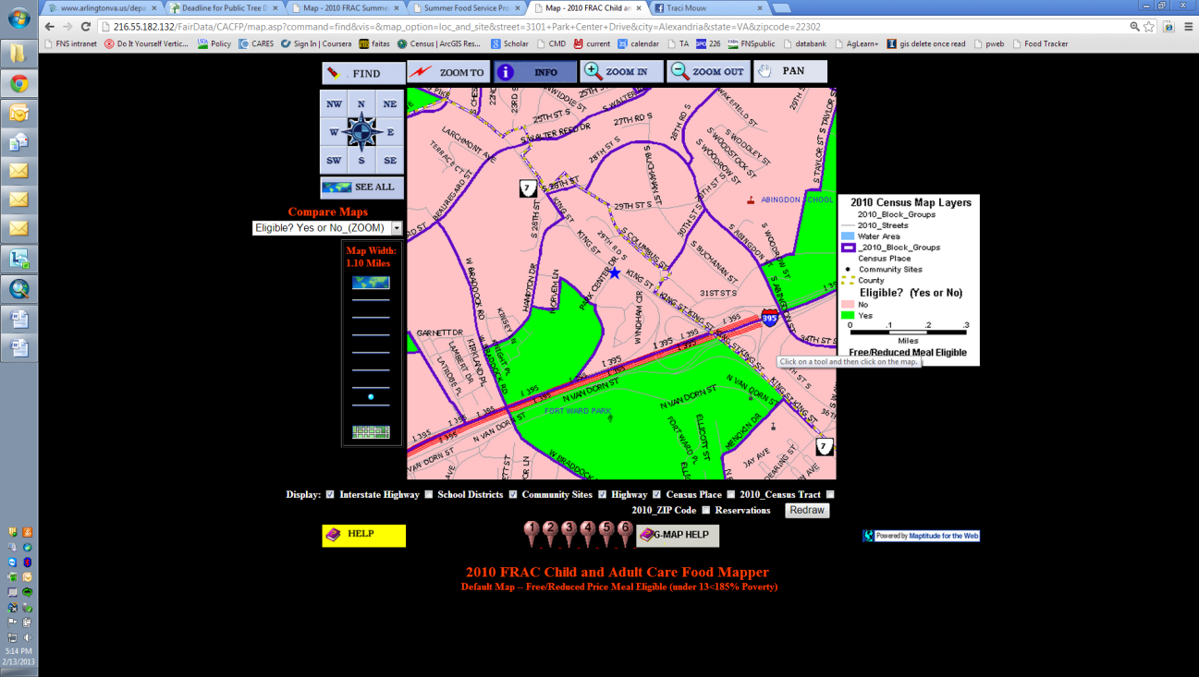If an address falls on a border between an eligible and ineligible CBG, click on the blue star and then INFO and scroll in the “2010 Block Group Information” window to “Eligible? (Yes or No).

**Step 2, Option 3: Combining CBGs:**

With both Texas Department of Agriculture (TDA) and United State Department of Agriculture (USDA) Food and Nutrition Service (FNS) Regional Office (RO) approval, areas that are ineligible using the method above may be eligible through a third method. Up to three adjacent CBGs where at least 40 percent or more of the children in each CBG are eligible for free or reduced-price meals may be combined to determine eligibility. If combining the adjacent CBGs results in a weighted average of 50 percent or more free and reduced-price eligible, the CBG can be considered eligible.

Averaging adjacent CBGs is meant to address pockets of poverty near census eligible CBGs. In other words, this method allows for the area around a day care home or site to be expanded to address nearby areas of high need.

In order to properly calculate the weighted average, it is important that:

* Only up to three CBGs are averaged, and one of these must include the CBG where the day care home or site is located.
* All CBGs included in the weighted average have 40 percent or more children eligible for free or reduced-price meals
* The CBGs are adjacent to, or share a border with the CBG where the day care home or site is located.
* Either data for CACFP (0-12 year olds) or SFSP, SSO, and ASCP (0-18 year olds) is used to determine the weighted average. Either of these numerators and denominators may be used to determine eligibility using the weighted average but the same data set must be used across CBGs.

Instructions for using the FNS Mapper:

1. Follow the instructions above to find the location of the day care home or site.
2. Click on the Legend box on the left side of the screen if it does not automatically display and use the information in the display to determine the eligibility of each CBG.
3. Use the + and – icons on the map to resize the map to see adjacent CBGs.
4. Click on the ineligible CBG to get the information needed to determine if at least 40 percent or more of the children in each of the CBGs to be combined are eligible for free and reduced-price meals by dividing either:
   1. the Num18pov (Numerator) /Total18inBG (Denominator); or
   2. the Num12pov (Numerator)/ Total12inBG (Denominator)

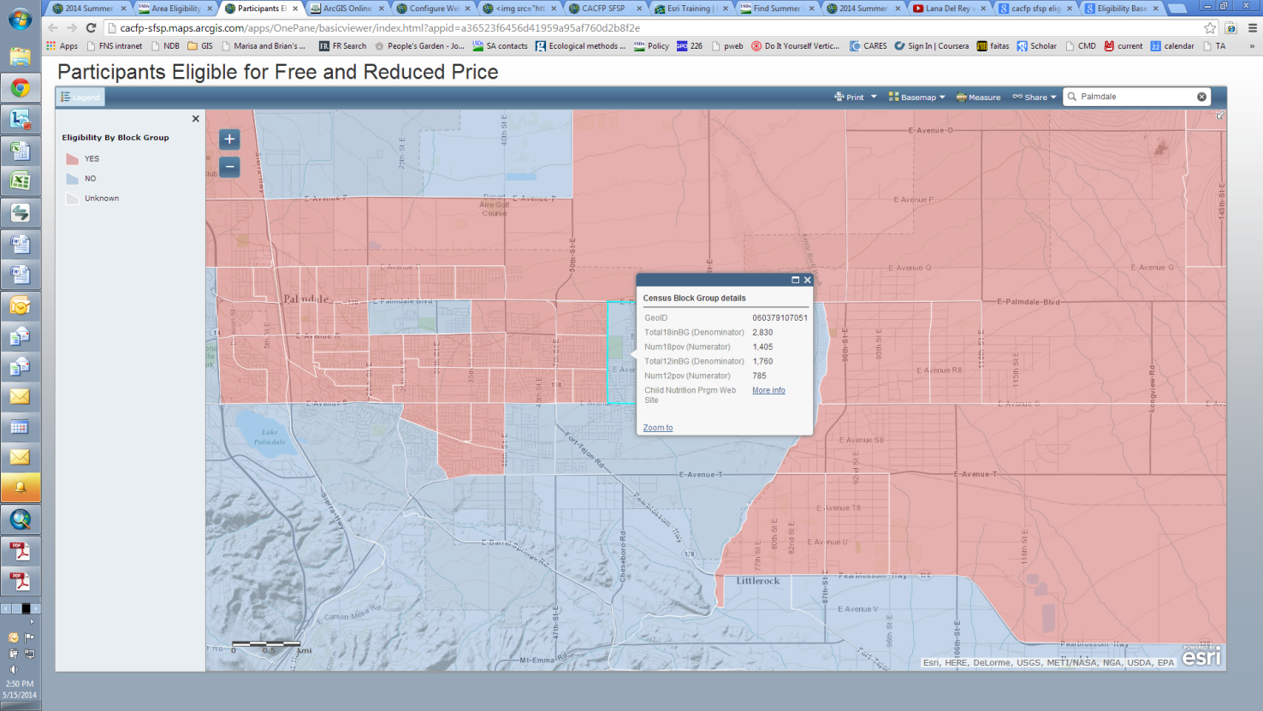

These fields represent the number of 0-18 year olds and the number of 0-12 year olds in the CBG

1. If at least 40 percent or more of the children in each of the combined CBGs are eligible for free and reduced-price meals, then proceed with the weighted average by making the following calculations:
   1. Add the numerators for the CBG where the site is located, and up to two additional adjacent CBG’s with over 40 percent free or reduced-price eligibility. Determine if the adjacent CBGs have at least 40 percent eligibility by using the method in step 2 above.
   2. Add the denominators in the same way.
   3. Divide the sum of the numerators by the sum of the denominators and multiplying by 100%. If that percentage is 50 percent or above the CBG can be considered area eligible with TDA and USDA FNS RO approval.

**Example:**

|  |  |  |  |  |
| --- | --- | --- | --- | --- |
| Palmdale, California |  |  |  | |
| CBG GEOID | Numerator (Num18pov) | Denominator (Total18inBG) | Percentage (Numerator/Denominator) x 100%  *must be at least 40%) | |
| 60379107051 | 1,405 | 2,830 | x 100% | 49.65% |
| 60379107131 | 435 | 680 | x 100% | 63.97% |
| 60379107141 | 855 | 955 | x 100% | 89.53% |
| Total | Sum of Numerators (1405+435+855) | Sum of Denominators  (2830+680+955) | Weighted average percent = (Sum of Numerators)/(Sum of Denominators) x 100% | |
|  | 2,695 | 4,465 | x 100% | 60.36% |

**Step 3, Option 3: Combining CBGs – Approval Request to TDA:**

To request approval, submit to TDA the following information:

* Provider Name or Site Name
* Provider or Site Address, including City, State, and Zip
* Provider or Site Census Block Group
* Identify if using CACFP Data or SFSP Data (same must be used for each contiguous CBGs)
* Provider or Site Data Numerator (Num18pov or Num12pov)
* Provider or Site Data Denominator (Total18inBG or Total12inBG)
* First Contiguous CBG Number
* First Contiguous CBG Data Numerator (Num18pov or Num12pov)
* First Contiguous CBG Data Denominator(Total18inBG or Total12inBG)
* Second Contiguous CBG Number
* Second Contiguous CBG Data Numerator (Num18pov or Num12pov)
* Second Contiguous CBG Data Denominator(Total18inBG or Total12inBG)
* Combined CBG Calculation
* Screen shots from FRAC Mapper and/or FNS Area Eligibility Mapper showing Provider/Site CBG location and contiguous CBGs location.

**Submit requests to:**

**Email to**: [FNDPolicy@Texasagriculture.gov](mailto:FNDPolicy@Texasagriculture.gov)

Subject: Area Eligibility Based on Combined Census Block Groups

**Fax to**: 888-237-4864

Attn: Coordinator for Policy

Subject: Area Eligibility Based on Combined Census Block Groups

**Mail to:**

Texas Department of Agriculture

Food and Nutrition

Attn: Coordinator for Policy

P.O. Box 12847

Austin, Texas 78711

**Overnight to**:

Texas Department of Agriculture

Food and Nutrition

Attn: Coordinator for Policy

1700 North Congress Ave.

Austin, Texas 78701

**MAKE SURE YOUR CE NAME AND CE ID IS ON ALL DOCUMENTS SUBMITTED.**