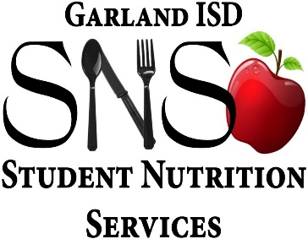
Breakfast in the Classroom
Teachers,
The following instructions are provided for administering breakfast in the classroom:
- Each student will be provided a breakfast. If the student does not want breakfast, they are not required to have breakfast.
- Students MUST be allowed to take their choice of milk (unless they are Pre-K, then white milk must be taken). Students are not required to select a milk if they are not Pre-K. If a student selects a milk but does not choose to drink the milk, it CANNOT be saved or returned in the cooler. All selected milks MUST be thrown away, even if unopened. Unselected milk should be left in the cooler.
- On your classroom worksheet, place a check mark in the first box by the student’s name if they took a breakfast. If the student did not choose to take a breakfast, leave the box blank. This must be done at the point of service when the student is receiving the meal.
- Return any leftover breakfast items and milk, as well as the daily rosters to the cafeteria (by leaving your coolers outside your classroom door). “Saving” or “keeping” unselected items is not allowed. All unused items must be returned to the cafeteria.
- If you have a student in your class who is not on your sheet, please write their name and ID# at the bottom of the Classroom Worksheet with a check mark to show that they received breakfast.
Garland ISD Student Nutrition Services appreciates your help in making Breakfast in the Classroom a success!!!

