Texas Unified Nutrition Programs System
(TX-UNPS) Project

SNP Site Claims

Point of Sale (POS) File Specifications

Final V2.0

June 25, 2014

State of Texas  Department of Agriculture  Food and Nutrition Division | 

Submitted by:


22420 N. 18th Drive
Phoenix, Arizona, 85027
623-209-1700

Table of Contents
1. Point of Sale (POS) Interface 4
1.1 Interface Characteristics 4
1.2 Constraints 5
1.3 Process Overview 5
1.4 File Layout 6
2. Accessing SNP Site Claim POS Option within TX-UNPS 6

Document Revision History
Version | Status | Date | Change Description | Updated By
V.01 | Draft | 11/30/2010 | Initial draft submitted to TX-UNPS Project Management Team for review | Simona Handley
V.01 | Draft | 04/10/2011 | Inserted Appendix A | Simona Handley
V.02 | Draft | 04/18/2011 | TDA review of draft document with comments | Ed Kelly
V1.0 | Final | 04/19/2011 | Final specifications | Simona Handley
V1.1 | Final | 11/17/2011 | Updated to accommodate Provision 2 sites in POS upload data file; no change to file format; however, some data fields are completed differently if Provision 2 site | Simona Handley
V2.0 | Final | 06/25/2014 | Updated to accommodate Community Eligibility Provision (CEP). Changes to Appendix A.  - Instructional changes: Instructional changes to several fields to change from “Provision 2” to “Provisional” to encompass CEP; no structure change  - File structure change: Added fields 59 and 60 | Simona Handley

- Point of Sale (POS) Interface
School Nutrition Program (SNP) site claim data may be either manually entered into TX-UNPS via the SNP Claims module or imported via a file in a designated, pre-defined file format. Since some Contracting Entities maintain meal administrative systems that automatically capture point of sale (POS) data for meals served and generate reimbursement claims by site, TX-UNPS provides the ability for authorized users to import a POS file in a defined file format. Once the file is imported into TX-UNPS, claim validation and error checking will function in the same manner as if the site data was manually entered into TX-UNPS and the user had selected the Save button.
This interface will accommodate non-Provisional and Provisional sites in a single data file.
This option is available only for the School Nutrition Program (SNP), which includes the following:
- National School Lunch Program (NSLP).
- School Breakfast Program (SBP).
- Afterschool Care Program (ASCP).
- Special Milk Program (SMP).

Interface Characteristics
The following table identifies the characteristics of this interface:
Table 1: POS Systems – Interface Characteristics
Category | Characteristic
Purpose of Interface(s) | To upload a Contracting Entity’s SNP site-level claim data
Type of Interface(s) | Batch
Initial Frequency Setting | On-demand initiated by Contracting Entity user
Interface Direction | Import into TX-UNPS
Import Method | Via YYYY-YYYY SNP Claim Site List screen within the TX-UNPS SNP Claims module (see Section 2)
Acceptable File Formats | ASCII Fixed Width per specification in this document
TDA Contact | TX-UNPS Help Desk

Constraints
The import process relies on the creation of an interface file that is a fixed width ASCII text file and contains site-level claim reporting information from a Contracting Entity’s point of sale (POS) system. The file must be formatted according to the layout specified in the TX-UNPS SNP POS File Layout specifications. Contracting Entities will need to develop a method of creating this file, which may require working with their POS vendor.
Any questions regarding the process or defined file format should be directed to the following TDA contact:
- squaremeals@texasagriculture.gov

Process Overview
Creating the TX-UNPS SNP Claims POS File
When a Contracting Entity is ready to import site claim data into TX-UNPS for a specific month, they will initially execute an external process from their POS system to create the “import” file. This file can be saved on the Contracting Entity’s local computer hard drive, network directory, or in any location desired by the user. The name of the file is not relevant to TX-UNPS, therefore the Contracting Entity can choose their own naming standard for the file. It is recommended that the Contracting Entity includes the claim month (e.g., Feb2015) in the file name.
Importing the SNP Claims POS File into TX-UNPS
Once the file is created, the user will log into TX-UNPS to execute the import process. The interface process is initiated by a user with the appropriate TX-UNPS security to load the file. The intent is for the Contracting Entity user to conduct the upload process; however, any authorized user, including ESCs and TDA staff, can upload a file given the proper TX-UNPS security rights and access to the SNP Claims POS file.
To upload the file into TX-UNPS, the Contracting Entity will click on a button on the TX-UNPS SNP Claim Site List screen (see Section 2). TX-UNPS will present the user with a “File Open” dialog box and the user will navigate to and select the “import” file from the location where the user saved the file. After selecting the file, the user will click on an “import” link. TX-UNPS will import the file and save the data. Uploaded files will be validated to ensure that Contracting Entities can only upload data for their sites.
Data Validation
After the file has been imported, TX-UNPS will display a results screen so the user understands which, if any, records needs to be corrected. If there are errors in the data, the user can either correct them manually in TX-UNPS or correct the errors in the POS system and re-upload the corrected file. The file can be uploaded as many times as the Contracting Entity would like; however, TX-UNPS will overlay any existing data with new data. Repetitive uploads will always overlay existing data until the claim is paid. After the claim for the month being uploaded is paid, subsequent uploads for the same month will result in the creation of a revised claim.

File Layout
Appendix A defines the file format for the TX-UNPS SNP Claims POS file. Please note the following:
- N = Numeric
Example: Numeric data that is represented with two digits and no decimal places will be shown in this document as N(2,0).
- C = Character
Example: Character data that fills a field that is 64 spaces wide will be shown in this document as C(64).
- Accessing SNP Site Claim POS Option within TX-UNPS
The following screens identify the steps required to upload SNP site claims data.

Step 1: Access the SNP Claims Sub-module
Once an authorized user has logged into the SNP module, access to the claims component for SNP Claims is via “Claims” on the Menu Bar.

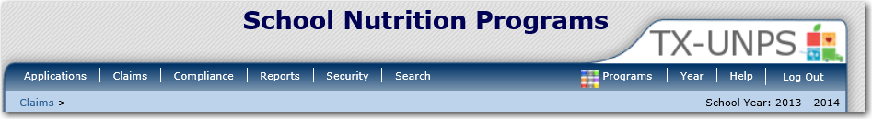

Step 2: Select “Claim – SNP”
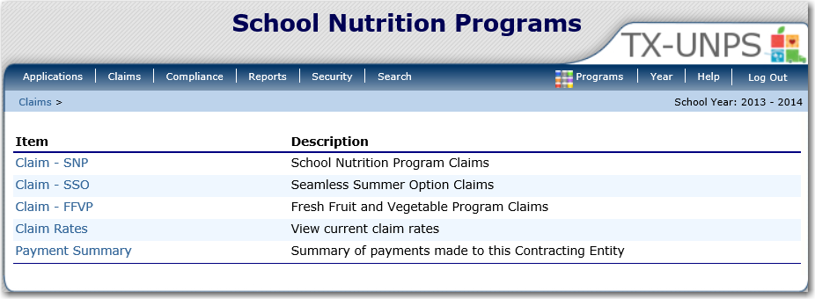

Step 3: On the SNP Claim Year Summary screen, select Claim Month for the file to be uploaded
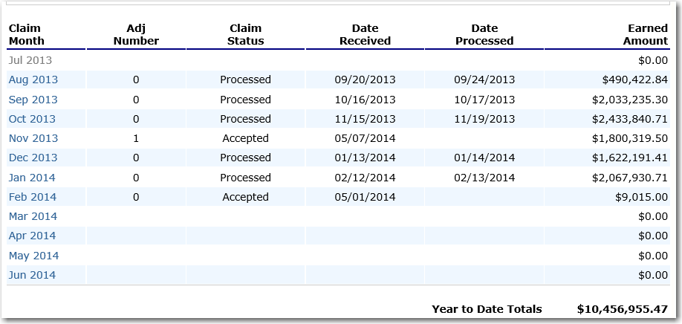

Step 4: On the SNP Claim Month Details screen, select the “Add Original Claim” button
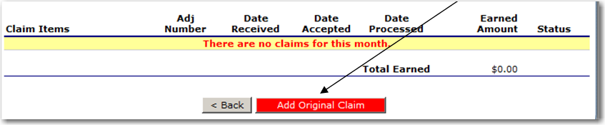
Step 5a: Select the “Upload Claim Data” button
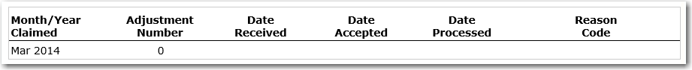

Step 5b: Select the POS claim file to be uploaded (use the Browse button to locate the file)
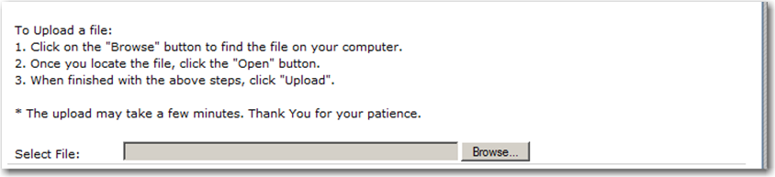

Step 5c: Select the “Upload” button
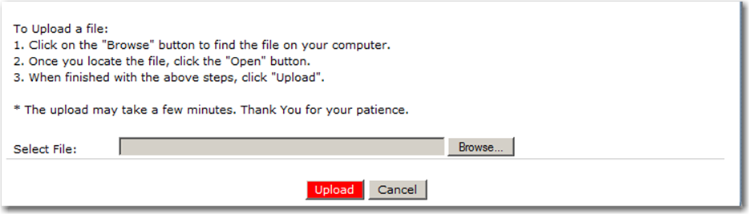

Appendix A

TX-UNPS SNP Point of Sale (POS) File Format Specifications

Notes:
- Each row in the POS file is a site claim for a respective claim month; multiple sites (i.e., records) are included in a single POS file.
- Fields related to each meal type are grouped and identified as follwos:
  - “L” fields = National School Lunch Program
  - “B” fields = School Breakfast Program (Regular)
  - “N” fields = School Breakfast Program (Severe Need)
  - “AN” fields = Afterschool Care Program (Non-Area Eligible)
  - “AE” fields = Afterschool Care Program (Area Eligible)
  - “M” fields = Special Milk
- If a site is claiming for a specific meal type (ex. Lunch), ensure that all related fields are completed correctly (e.g., “L” fields)
- A single POS file may contain Provisional and non-Provisional sites.
- TX-UNPS knows which sites are Provisional based on its Site ID and program year. However, some of the data contained in the record would vary for Provisional vs. non-Provisional sites. See the Instructions column for each field for more information.

Field Seq. | Position From | Position To | Description | Field Length | Field Type | Required Field? | Instructions
1 | 1 | 3 | Upload Form ID | 3 | N(3,0) | Y | Claim General Information  Insert value = 703 for every record
2 | 4 | 9 | Sequential Number | 6 | N(6,0) | Y | Claim General Information  Sequential Record Number (1, 2, 3, etc.)  The sequential number MUST be unique within a POS file
3 | 10 | 17 | Process Date | 8 | N(8,0) | N | Claim General Information  Date the Contracting Entity exported the data from their system  Format: MMDDYYYY  NOTE: This data is not stored or used within TX-UNPS; however, it may be useful to the Contracting Entity
4 | 18 | 81 | Contracting Entity Name | 64 | C(64) | Y | Claim General Information  Name of the Contracting Entity (as indicated within TX-UNPS)
5 | 82 | 86 | Contracting Entity ID | 5 | C(5) | Y | Claim General Information  Unique five digit Contracting Entity ID that was system generated by TX-UNPS; this MUST match the CE ID defined within TX-UNPS.  Zero fill from left (e.g. 01234)
6 | 87 | 150 | Site Name | 64 | C(64) | Y | Claim General Information  Name of the Site (as indicated within TX-UNPS).
7 | 151 | 154 | Site ID | 4 | C(4) | Y | Claim General Information  Unique four digit Site ID maintained within TX-UNPS; this MUST match the Site ID defined within TX-UNPS.  Zero fill from left (e.g., 0114)
8 | 155 | 156 | Claim Month | 2 | N(2,0) | Y | Claim General Information  The two-digit calendar month for which the claim is being submitted  Example: January = 01; February = 02, etc.
9 | 157 | 160 | Claim Year | 4 | N(4,0) | Y | Claim General Information  The four digit calendar year for which the claim is being submitted  Example: 2011
10 | 161 | 167 | G1 - Number of Children Approved for Free Meals | 7 | N(7,0) | N | SNP General Information  If site is not claiming Lunch or Breakfast for this claim month, leave blank  If non-Provisional site participating in Lunch (L fields), Breakfast (B fields) or Severe Need Breakfast (N fields), enter number of children approved for free meals  If Provisional site, leave blank
11 | 168 | 174 | G2 - Number of Children Approved for Reduced Price Meals | 7 | N(7,0) | N | SNP General Information  If site is not claiming Lunch or Breakfast for this claim month, leave blank  If non-Provisional site participating in Lunch (L fields), Breakfast (B fields) or Severe Need Breakfast (N fields), enter number of children approved for reduced price meals  If Provisional site, leave blank
12 | 175 | 181 | G3 - Number of Enrolled Children | 7 | N(7,0) | N | SNP General Information  If site is not claiming Lunch or Breakfast for this claim month, leave blank  If site is claiming Lunch or Breakfast (regardless if it is a Provisional site or a non-Provisional site), enter number of enrolled children
13 | 182 | 188 | L1 - Authorized Sites Participating | 7 | N(7,0) | N | Complete if participating in National School Lunch Program  If site is not claiming this program for this claim month, leave blank  If site is claiming for this program for this claim month, enter “1”
14 | 189 | 195 | L2 - Total Monthly Attendance | 7 | N(7,0) | N | Complete if participating in National School Lunch Program  If site is not claiming this program for this claim month, leave blank  If site is claiming Lunch (regardless if it is Provisional site or a non-Provisional site), enter total monthly attendance (i.e., the sum of each day’s attendance for the entire month)
15 | 196 | 197 | L3 - Number Operating Days | 2 | N(2,0) | N | Complete if participating in National School Lunch Program  If site is not claiming this program for this claim month, leave blank  If site is claiming Lunch (regardless if it is Provisional site or a non-Provisional site), enter number of operating days
16 | 198 | 204 | L4a - Free Reimbursable Lunches Served | 7 | N(7,0) | N | National School Lunch Program  If site is not claiming this program for this claim month, leave blank  If non-Provisional site, enter number of free reimbursable lunches served  If Provisional site, leave blank
17 | 205 | 211 | L4b - Reduced Price Reimbursable Lunches Served | 7 | N(7,0) | N | National School Lunch Program  If site is not claiming this program for this claim month, leave blank  If non-Provisional site, enter number of reduced price reimbursable lunches served  If Provisional site, leave blank
18 | 212 | 218 | L4c - Paid Reimbursable Lunches Served | 7 | N(7,0) | N | National School Lunch Program  If site is not claiming this program for this claim month, leave blank  If non-Provisional site, enter number of paid reimbursable lunches served  If Provisional site, leave blank
19 | 219 | 225 | L4d- Total Lunches Served (a + b + c) | 7 | N(7,0) | N | National School Lunch Program  If site is not claiming this program for this claim month, leave blank  If non-Provisional site, enter sum of L4a+L4b+L4c  If Provisional site, enter total lunches served
20 | 226 | 232 | B1 - Authorized Sites Participating | 7 | N(7,0) | N | Complete if participating in School Breakfast Program (Regular Reimbursement)  If site is not claiming this program for this claim month, leave blank  If site is claiming for this program for this claim month, enter “1”
21 | 233 | 239 | B2 - Total Monthly Attendance | 7 | N(7,0) | N | Complete if participating in School Breakfast Program (Regular Reimbursement)  If site is not claiming this program for this claim month, leave blank  If site is claiming Breakfast (regardless if it is Provisional site or a non-Provisional site), enter total monthly attendance (i.e., the sum of each day’s attendance for the entire month)
22 | 240 | 241 | B3 - Number Operating Days | 2 | N(2,0) | N | Complete if participating in School Breakfast Program (Regular Reimbursement)  If site is not claiming this program for this claim month, leave blank  If site is claiming Breakfast (regardless if it is Provisional site or a non-Provisional site), enter number of operating days
23 | 242 | 248 | B4a - Free Reimbursable Breakfasts Served | 7 | N(7,0) | N | School Breakfast Program (Regular Reimbursement)  If site is not claiming this program for this claim month, leave blank  If non-Provisional site, enter number of free reimbursable breakfasts served  If Provisional site, leave blank
24 | 249 | 255 | B4b - Reduced Price Reimbursable Breakfasts Served | 7 | N(7,0) | N | School Breakfast Program (Regular Reimbursement)  If site is not claiming this program for this claim month, leave blank  If non-Provisional site, enter number of reduced price reimbursable breakfasts served  If Provisional site, leave blank
25 | 256 | 262 | B4c - Paid Reimbursable Breakfasts Served | 7 | N(7,0) | N | School Breakfast Program (Regular Reimbursement)  If site is not claiming this program for this claim month, leave blank  If non-Provisional site, enter number of paid reimbursable breakfasts served  If Provisional site, leave blank
26 | 263 | 269 | B4d - Total Reimbursable Breakfasts Served | 7 | N(7,0) | N | School Breakfast Program (Regular Reimbursement)  If site is not claiming this program for this claim month, leave blank  If non-Provisional site, enter sum of B4a+B4b+B4c  If Provisional site, enter total breakfasts served
27 | 270 | 276 | N1 - Authorized Sites Participating | 7 | N(7,0) | N | School Breakfast Program (Severe Need Reimbursement)  If site is not claiming this program for this claim month, leave blank
28 | 277 | 283 | N2 - Total Monthly Attendance | 7 | N(7,0) | N | Complete if participating in School Breakfast Program (Severe Need Reimbursement)  If site is not claiming this program for this claim month, leave blank  If site is claiming Breakfast (regardless if it is Provisional site or a non-Provisional site), enter total monthly attendance (i.e., the sum of each day’s attendance for the entire month)
29 | 284 | 285 | N3 - Number Operating Days | 2 | N(2,0) | N | Complete if participating in School Breakfast Program (Severe Need Reimbursement)  If site is not claiming this program for this claim month, leave blank  If site is claiming Breakfast (regardless if it is Provisional site or a non-Provisional site), enter number of operating days
30 | 286 | 292 | N4a - Free Reimbursable Breakfasts Served | 7 | N(7,0) | N | School Breakfast Program (Severe Need Reimbursement)  If site is not claiming this program for this claim month, leave blank  If non-Provisional site, enter number of free reimbursable breakfasts served  If Provisional site, leave blank
31 | 293 | 299 | N4b - Reduced Price Reimbursable Breakfasts Served | 7 | N(7,0) | N | School Breakfast Program (Severe Need Reimbursement)  If site is not claiming this program for this claim month, leave blank  If non-Provisional site, enter number of reduced price reimbursable breakfasts served  If Provisional site, leave blank
32 | 300 | 306 | N4c - Paid Reimbursable Breakfasts Served | 7 | N(7,0) | N | School Breakfast Program (Severe Need Reimbursement)  If site is not claiming this program for this claim month, leave blank  If non-Provisional site, enter number of paid reimbursable breakfasts served  If Provisional site, leave blank
33 | 307 | 313 | N4d - Total Reimbursable Breakfasts Served | 7 | N(7,0) | N | School Breakfast Program (Severe Need Reimbursement)  If site is not claiming this program for this claim month, leave blank  If non-Provisional site, enter sum of N4a+N4b+N4c  If Provisional site, enter total breakfasts served
34 | 314 | 320 | AN1 - Number of Children Approved for Free Snacks (Non-Area Eligible) | 7 | N(7,0) | N | Afterschool Care Program (Non Area Eligible)  If site is not claiming this program for this claim month, leave blank
35 | 321 | 327 | AN2 - Number of Children Approved for Reduced Snacks (Non-Area Eligible) | 7 | N(7,0) | N | Afterschool Care Program (Non Area Eligible)  If site is not claiming this program for this claim month, leave blank
36 | 328 | 334 | AN3 - Number of Enrolled Children (Non-Area Eligible) | 7 | N(7,0) | N | Afterschool Care Program (Non Area Eligible)  If site is not claiming this program for this claim month, leave blank
37 | 335 | 341 | AN4 - Authorized Sites Participating (Non-Area Eligible) | 7 | N(7,0) | N | Afterschool Care Program (Non Area Eligible)  If site is not claiming this program for this claim month, leave blank  If site is claiming for this program for this claim month, enter “1”
38 | 342 | 348 | AN5 - Total Monthly Attendance (Non-Area Eligible) | 7 | N(7,0) | N | Afterschool Care Program (Non Area Eligible)  If site is not claiming this program for this claim month, leave blank
39 | 349 | 350 | AN6 - Number Operating Days (Non-Area Eligible) | 2 | N(2,0) | N | Afterschool Care Program (Non Area Eligible)  If site is not claiming this program for this claim month, leave blank
40 | 351 | 357 | AN7a - Free Snacks Served (Non-Area Eligible) | 7 | N(7,0) | N | Afterschool Care Program (Non Area Eligible)  If site is not claiming this program for this claim month, leave blank
41 | 358 | 364 | AN7b - Reduced Snacks Served (Non-Area Eligible) | 7 | N(7,0) | N | Afterschool Care Program (Non Area Eligible)  If site is not claiming this program for this claim month, leave blank
42 | 365 | 371 | AN7c - Paid Snacks Served (Non-Area Eligible) | 7 | N(7,0) | N | Afterschool Care Program (Non Area Eligible)  If site is not claiming this program for this claim month, leave blank
43 | 372 | 378 | AN7d - Total Snacks Served (Non-Area Eligible) | 7 | N(7,0) | N | Afterschool Care Program (Non Area Eligible)  Enter sum of AN7a+AN4b+AN7c  If site is not claiming this program for this claim month, leave blank
44 | 379 | 385 | AE1 - Number of Children Approved for Free Snacks (Area Eligible) | 7 | N(7,0) | N | Afterschool Care Program (Area Eligible)  If site is not claiming this program for this claim month, leave blank
45 | 386 | 392 | AE3 - Number of Enrolled Children (Area Eligible) | 7 | N(7,0) | N | Afterschool Care Program (Area Eligible)  If site is not claiming this program for this claim month, leave blank .  Enter value in AE1
46 | 393 | 399 | AE4 - Authorized Sites Participating (Area Eligible) | 7 | N(7,0) | N | Afterschool Care Program (Area Eligible)  If site is not claiming this program for this claim month, leave blank  If site is claiming for this program for this claim month, enter “1”
47 | 400 | 406 | AE5 - Total Monthly Attendance (Area Eligible) | 7 | N(7,0) | N | Afterschool Care Program (Area Eligible)  If site is not claiming this program for this claim month, leave blank
48 | 407 | 408 | AE6 - Number Operating Days (Area Eligible) | 2 | N(2,0) | N | Afterschool Care Program (Area Eligible)  If site is not claiming this program for this claim month, leave blank
49 | 409 | 415 | AE7a - Free Snacks Served (Area Eligible) | 7 | N(7,0) | N | Afterschool Care Program (Area Eligible)  If site is not claiming this program for this claim month, leave blank
50 | 416 | 422 | AE7d - Total Snacks Served (Area Eligible) | 7 | N(7,0) | N | Afterschool Care Program (Area Eligible)  Enter value in AE7a  If site is not claiming this program for this claim month, leave blank
51 | 423 | 429 | M1 - Number of Fluid Milk 1/2 Pints Purchased | 7 | N(7,0) | N | Special Milk Program  If site is not claiming this program for this claim month, leave blank
52 | 430 | 436 | M2 - Total Cost of Fluid Milk Purchased This Month | 7 | N(7,2) | N | Special Milk Program  If site is not claiming this program for this claim month, leave blank  If site is claiming for this month, the total cost must include a decimal point
53 | 437 | 443 | M3 - Authorized Sites Participating | 7 | N(7,0) | N | Special Milk Program  If site is not claiming this program for this claim month, leave blank  If site is claiming for this program for this claim month, enter “1”
54 | 444 | 450 | M4 - Total Monthly Attendance | 7 | N(7,0) | N | Special Milk Program  If site is not claiming this program for this claim month, leave blank
55 | 451 | 452 | M5 - Number Operating Days | 2 | N(2,0) | N | Special Milk Program  If site is not claiming this program for this claim month, leave blank
56 | 453 | 459 | M6a - Free Milk Served | 7 | N(7,0) | N | Special Milk Program  If site is not claiming this program for this claim month, leave blank
57 | 460 | 466 | M6b - Paid Milk Served | 7 | N(7,0) | N | Special Milk Program  If site is not claiming this program for this claim month, leave blank
58 | 467 | 473 | M6c - Total Milk Served | 7 | N(7,0) | N | Special Milk Program  Enter sum of M6a+M6b  If site is not claiming this program for this claim month, leave blank
59 | 474 | 481 | Provision Type - Lunch | 8 | C(8) | N | Provisional Indicator  If the site does NOT participate in a provisional program for Lunch: Leave blank  If the site participates in Provision 2 for Lunch, enter “PROV2”  If the site participates in CEP for Lunch, enter “CEP”
60 | 482 | 489 | Provision Type - Breakfast | 8 | C(8) | N | Provisional Indicator  If the site does NOT participate in a provisional program for Breakfast leave blank  If the site participates in Provision 2 for Breakfast, enter “PROV2”  If the site participates in CEP for Breakfast, enter “CEP”

