Texas Unified Nutrition Programs System (TX-UNPS) Project

Fresh Fruit and Vegetable (FFVP) Site Claims

Point of Sale (POS) File Specifications

Final V1.1

May 15, 2012

State of Texas  Department of Agriculture  Food and Nutrition Division | 

Submitted by:


22420 N. 18th Drive
Phoenix, Arizona, 85027
623-209-1700

Table of Contents
1. Point of Sale (POS) Interface 4
1.1 Interface Characteristics 4
1.2 Constraints 4
1.3 Process Overview 5
1.4 File Layout 6
2. Accessing SNP’s FFVP Site Claim POS Option within TX-UNPS 7
Appendix A 10

Document Revision History
Version | Status | Date | Change Description | Updated By
V1.0 | Final | 03/26/2012 | Submitted to TX-UNPS Project Management Team | Simona Handley
V1.1 | Final | 05/15/2012 | Within Appendix:  - Added bullet on Appendix cover re: system edits and yellow exclamation point warnings  - Updated description of Field 2 requesting that it is unique for each record in a Sponsor’s POS file  - Updated description on Field 11 regarding maximum number of operating days used by TX-UNPS on the FFVP claim screen  - Updated description of Field 15 and 16 to state decimal points are optional and that 4 decimal places may be displayed as 2 decimal places on the TX-UNPS FFVP claim screen | Simona Handley

- Point of Sale (POS) Interface
School Nutrition Program (SNP) Fresh Fruit and Vegetable Program (FFVP) site claim data may be either manually entered into TX-UNPS via the FFVP Claims screens (located within the SNP module) or imported via a file in a designated, pre-defined file format. Since some Contracting Entities maintain meal administrative systems that automatically capture point of sale (POS) data for meals served and generate reimbursement claims by site, TX-UNPS provides the ability for authorized users to import a POS file in a defined file format. Once the file is imported into TX-UNPS, claim validation and error checking will function in the same manner as if the site data was manually entered into TX-UNPS and the user had selected the Save button.

Interface Characteristics
The following table identifies the characteristics of this interface:
Table 1: POS Systems – Interface Characteristics
Category | Characteristic
Purpose of Interface(s) | To upload a Contracting Entity’s Fresh Fruit and Vegetable Program (FFVP) site-level claim data
Type of Interface(s) | Batch
Initial Frequency Setting | On-demand initiated by Contracting Entity user
Interface Direction | Import into TX-UNPS
Import Method | Via YYYY-YYYY Fresh Fruit and Vegetable Claim Site List screen within the TX-UNPS SNP FFVP Claims module (see Section 2)
Acceptable File Formats | ASCII Fixed Width per specification in this document
TDA Contact for Development Questions | - Meredith Noel  - Meredith.noel@texasagriculture.gov  - 512-463-4293
TDA Contact for Production Questions | - TX-UNPS Help Desk  - squaremeals@TexasAgriculture.gov  - 1-877-TEX-MEAL

Constraints
The import process relies on the creation of an interface file that is a fixed width ASCII text file and contains site-level claim reporting information from a Contracting Entity’s point of sale (POS) system. The file must be formatted according to the layout specified in the TX-UNPS SNP FFVP POS File Layout specifications. Contracting Entities will need to develop a method of creating this file, which may require working with their POS vendor.

Process Overview
Creating the TX-UNPS SNP Fresh Fruit and Vegetable Site Claims POS File
When a Contracting Entity is ready to import site claim data into TX-UNPS for a specific month, they will initially execute an external process from their POS system to create the “import” file. This file can be saved on the Contracting Entity’s local computer hard drive, network directory, or in any location desired by the user. The name of the file is not relevant to TX-UNPS, therefore the Contracting Entity can choose their own naming standard for the file. It is recommended that the Contracting Entity includes the claim month (e.g., May 2012) in the file name.
Importing the SNP Fresh Fruit and Vegetable Site Claims POS File into TX-UNPS
Once the file is created, the user will log into TX-UNPS to execute the import process. The interface process is initiated by a user with the appropriate TX-UNPS security to load the file. The intent is for the Contracting Entity user to conduct the upload process; however, any authorized user, including ESCs and TDA staff, can upload a file given the proper TX-UNPS security rights and access to the SNP FFVP Claims POS file.
To upload the file into TX-UNPS, the Contracting Entity will click on the “Upload Claim Data” button on the TX-UNPS YYYY-YYYY Fresh Fruit and Vegetable Claim Site List screen (see Section 2). TX-UNPS will present the user with a “File Open” dialog box and the user will navigate to and select the “import” file from the location where the user saved the file. After selecting the file, the user will click on an “import” link. TX-UNPS will import the file and save the data. Uploaded files will be validated to ensure that Contracting Entities can only upload data for their sites.
Data Validation
After the file has been imported, TX-UNPS will display a results screen so the user understands which, if any, records needs to be corrected. If there are errors in the data, the user can either correct them manually in TX-UNPS or correct the errors in the POS system and re-upload the corrected file. The file can be uploaded as many times as the Contracting Entity would like; however, TX-UNPS will overlay any existing data with new data. Repetitive uploads will always overlay existing data until the claim is paid. After the claim for the month being uploaded is paid, subsequent uploads for the same month will result in the creation of a revised claim.

File Layout
Appendix A defines the file format for the TX-UNPS SNP Fresh Fruit and Vegetable Program Site Claims POS file. Please note the following:
- N = Numeric
Example: Numeric data that is represented with two digits and no decimal places will be shown in this document as N(2,0).
- C = Character
Example: Character data that fills a field that is 64 spaces wide will be shown in this document as C(64).
- Accessing SNP’s FFVP Site Claim POS Option within TX-UNPS
The following screens identify the steps required to upload Fresh Fruit and Vegetable Program site claims data.

Step 1: Access the SNP Claims Sub-module
Once an authorized user has logged into the SNP module, access to the claims component for FFVP-related Claims is via “Claims” on the Menu Bar.

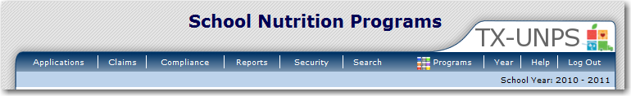

Step 2: Select “Claim – FFVP”
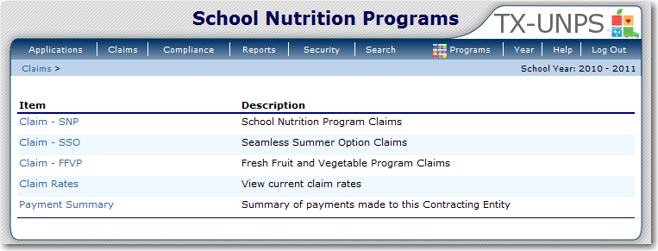

Step 3: On the FFVP Claim Year Summary screen, select Claim Month for the file to be uploaded
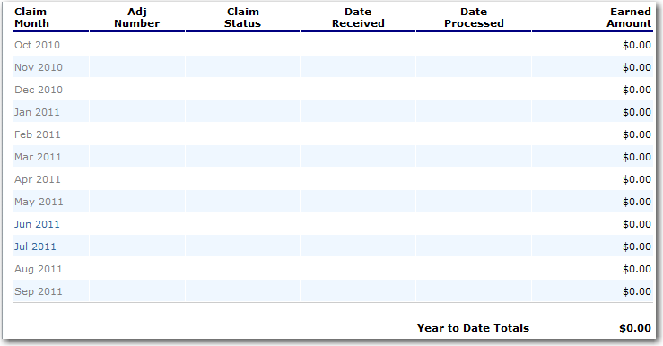

Step 4: On the Fresh Fruit and Vegetable Claim Month Details screen, select the “Add Original Claim” button
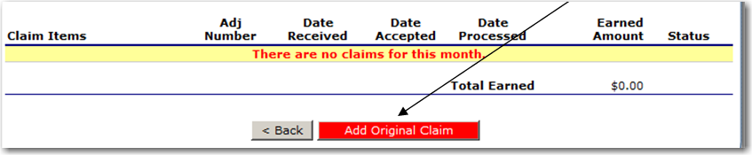
Step 5a: On the Fresh Fruit and Vegetable Claim Site List screen, select the “Upload Claim Data” button

Step 5b: Select the POS claim file to be uploaded (use the Browse button to locate the file)
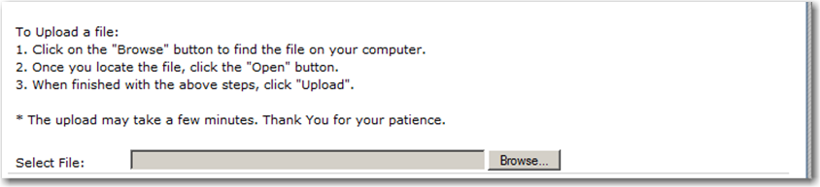

Step 5c: Select the “Upload” button
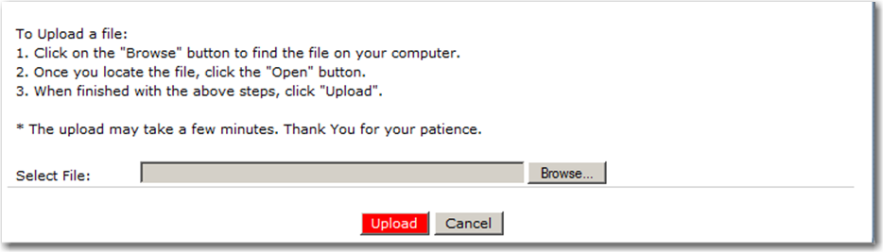

Appendix A

TX-UNPS

SNP Fresh Fruit and Vegetable Program (FFVP)

Point of Sale (POS) File Format Specifications

PLEASE NOTE:
- The POS tool provides the ability to upload data into TX-UNPS, saving time keying in each site claim. However, once data is uploaded into TX-UNPS, the system will perform additional edits on the data loaded. If any data field has a yellow exclamation mark icon, it is a warning that the user should check their data. An error message is displayed if your mouse hovers over the icon within the FFVP Claim screen.
- Each record in the POS file represents a combination of Contracting Entity, Site, Claim Month, and Line Item specifics (e.g., Fruit, Vegetable, Personnel, etc.); therefore, a single Contracting Entity/Site will have multiple records for a specific claim month.
- Although the POS file contains multiple records for a single Contracting Entity/Site/Claim Month, the entire group of rows associated with the site is treated by TX-UNPS as a “whole” site claim submission. If a Contracting Entity/Site/Claim Month is uploaded into TX-UNPS and then a secondary upload for the SAME Contracting Entity/Site/Claim Month occurs, all the original records uploaded are deleted and replaced with all the new records uploaded.
  - Example:
    - A Contracting Entity uploads a FFVP POS file whereby a specific Site contains 10 rows for a specific Claim Month (i.e., 10 items).
    - The Contracting Entity realizes an error in the data they uploaded and proceeds to upload another FFVP POS file; however, the Site now contains only 8 rows for a specific Claim Month (i.e., 8 items).
      - TX-UNPS treats the Contracting Entity/Site/Claim Month as a group and there will DELETE all of the original 10 records (i.e., items) from the TX-UNPS database and replaces the data with the 8 records (i.e., items).

Field Seq. | Position From | Position To | Description | Field Length | Field Type | Required Field? | Instructions
1 | 1 | 3 | Upload Form ID | 3 | N(3,0) | Y | Insert value = 201 for every record
2 | 4 | 9 | Sequential Number | 6 | N(6,0) | Y | Sequential Record Number (1, 2, 3, etc.)  The sequential number MUST be unique within a POS file
3 | 10 | 17 | Process Date | 8 | N(8,0) | N | Date the Contracting Entity exported the data from their system  Format: MMDDYYYY  NOTE: This data is not stored or used within TX-UNPS; however, it may be useful to the Contracting Entity
4 | 18 | 81 | Contracting Entity Name | 64 | C(64) | Y | Name of the Contracting Entity (as indicated within TX-UNPS)
5 | 82 | 86 | Contracting Entity ID | 5 | C(5) | Y | Claim General Information  Unique five digit Contracting Entity ID that was system generated by TX-UNPS; this MUST match the CE ID defined within TX-UNPS.  Zero fill from left (e.g. 01234)
6 | 87 | 150 | Site Name | 64 | C(64) | Y | Claim General Information  Name of the Site (as indicated within TX-UNPS).
7 | 151 | 154 | Site ID | 4 | C(4) | Y | Claim General Information  Unique four digit Site ID maintained within TX-UNPS; this MUST match the Site ID defined within TX-UNPS.  Zero fill from left (e.g., 0114)
8 | 155 | 156 | Claim Month | 2 | N(2,0) | Y | Claim General Information  The two-digit calendar month for which the claim is being submitted  Example: January = 01; February = 02, etc.  Valid values are 01 through 12
9 | 157 | 160 | Claim Year | 4 | N(4,0) | Y | Claim General Information  The four digit calendar year for which the claim is being submitted  Example: 2011
10 | 161 | 192 | Item/Record Type | 32 | C(32) | Y | Enter the type of item that this record is associated.  Valid values are:  -DURABLE_SUPPLIES_ADMIN  -FRESH_FRUIT  -FRESH_VEGETABLES  -OTHER_ADMIN_COST  -PERSONNEL_ADMIN  -PERSONNEL_OPER  -SUPPLIES_OTHER_OPER
11 | 193 | 194 | Number of Operating Days | 2 | N(2,0) | Y | Enter number of operating days.  This MUST be the same value for records associated with the same Site for the same Claim Month.  Example: If the number of Operating Days for Site 1234 is “22” for May 2012, all of the site’s records associated with the May 2012 claim should be “22”  NOTE: If different days are identified in the POS file, TX-UNPS will use the maximum number of days on the site claim
12 | 195 | 322 | Description | 128 | C(128) | Y | Enter Product Description if Item/Record Type is:  -DURABLE_SUPPLIES_ADMIN  -FRESH_FRUIT  -FRESH_VEGETABLES  -OTHER_ADMIN_COST  -SUPPLIES_OTHER_OPER  Enter Name/Position if Item/Record Type is:  -PERSONNEL_ADMIN  -PERSONNEL_OPER
13 | 323 | 338 | Size/Weight | 16 | C(16) | Conditional | Size/Weight is required for the following Item/Record Type:  -FRESH_FRUIT  -FRESH_VEGETABLES  This should be blank for all other Item/Record Types
14 | 339 | 345 | Number of Units/Quantity/Hours | 7 | N(7) | Y | May include decimal point – but not required  Whole numbers acceptable  Example: 10 can be submitted as 10 (no decimal point required)
15 | 346 | 363 | Cost Per Unit/Rate | 18 | N(18,4) | Y | Must exclude use of dollar signs and commas  Example: $1,123.56 should be 1123.56  May contain decimal point up to 4 places  Note: Once uploaded, the 4 place decimal is displayed up to 2 decimal places on the TX-UNPS FFVP screen
16 | 364 | 381 | Total Cost Per Unit/Quantity/Rate | 18 | N(18,4) | Y | TX-UNPS will not calculate this. Please ensure data represents:  Number of Units/Quantity/Hours X Cost Per Unit/Rate  Must exclude use of dollar signs and commas  Example: $123,554.56 should be 123554.56  May contain decimal point up to 4 places  Note: Once uploaded, the 4 place decimal is displayed up to 2 decimal places on the TX-UNPS FFVP screen

