Texas Unified Nutrition Programs System (TX-UNPS) Project

SNP Seamless Summer Site Claims

Point of Sale (POS) File Specifications

Final V1.1

March 12, 2012

State of Texas  Department of Agriculture  Food and Nutrition Division | 

Submitted by:


22420 N. 18th Drive
Phoenix, Arizona, 85027
623-209-1700

Table of Contents
1. Point of Sale (POS) Interface 4
1.1 Interface Characteristics 4
1.2 Constraints 5
1.3 Process Overview 5
1.4 File Layout 6
2. Accessing SNP Site Claim POS Option within TX-UNPS 7

Document Revision History
Version | Status | Date | Change Description | Updated By
V1.0 | Final | 02/29/2012 | Submitted to TX-UNPS Project Management Team | Simona Handley
V1.1 | Final | 03/12/2012 | Submitted to TX-UNPS Project Management Team | Simona Handley

- Point of Sale (POS) Interface
School Nutrition Program (SNP) Seamless Summer Option (SSO) site claim data may be either manually entered into TX-UNPS via the SSO Claims module or imported via a file in a designated, pre-defined file format. Since some Contracting Entities maintain meal administrative systems that automatically capture point of sale (POS) data for meals served and generate reimbursement claims by site, TX-UNPS provides the ability for authorized users to import a POS file in a defined file format. Once the file is imported into TX-UNPS, claim validation and error checking will function in the same manner as if the site data was manually entered into TX-UNPS and the user had selected the Save button.
This option is available only for the following Seamless Summer meals, which includes the following:
- National School Lunch Program (NSLP) – Free Lunches and Suppers.
- School Breakfast Program (SBP) – Free Breakfast.
- Afterschool Care Program (ASCP) – Free AM & PM Snacks.

Interface Characteristics
The following table identifies the characteristics of this interface:
Table 1: POS Systems – Interface Characteristics
Category | Characteristic
Purpose of Interface(s) | To upload a Contracting Entity’s Seamless Summer site-level claim data
Type of Interface(s) | Batch
Initial Frequency Setting | On-demand initiated by Contracting Entity user
Interface Direction | Import into TX-UNPS
Import Method | Via YYYY-YYYY SNP Claim Site List screen within the TX-UNPS SNP Seamless Summer Claims module (see Section 2)
Acceptable File Formats | ASCII Fixed Width per specification in this document
TDA Contact for Development Questions | - Meredith Noel  - Meredith.noel@texasagriculture.gov  - 512-463-4293
TDA Contact for Production Questions | - TX-UNPS Help Desk  - squaremeals@TexasAgriculture.gov  - 1-877-TEX-MEAL

Constraints
The import process relies on the creation of an interface file that is a fixed width ASCII text file and contains site-level claim reporting information from a Contracting Entity’s point of sale (POS) system. The file must be formatted according to the layout specified in the TX-UNPS SNP POS File Layout specifications. Contracting Entities will need to develop a method of creating this file, which may require working with their POS vendor.

Process Overview
Creating the TX-UNPS SNP Seamless Summer Claims POS File
When a Contracting Entity is ready to import site claim data into TX-UNPS for a specific month, they will initially execute an external process from their POS system to create the “import” file. This file can be saved on the Contracting Entity’s local computer hard drive, network directory, or in any location desired by the user. The name of the file is not relevant to TX-UNPS, therefore the Contracting Entity can choose their own naming standard for the file. It is recommended that the Contracting Entity includes the claim month (e.g., May2012) in the file name.
Importing the SNP Seamless Summer Claims POS File into TX-UNPS
Once the file is created, the user will log into TX-UNPS to execute the import process. The interface process is initiated by a user with the appropriate TX-UNPS security to load the file. The intent is for the Contracting Entity user to conduct the upload process; however, any authorized user, including ESCs and TDA staff, can upload a file given the proper TX-UNPS security rights and access to the SNP Seamless Summer Claims POS file.
To upload the file into TX-UNPS, the Contracting Entity will click on a button on the TX-UNPS SNP Seamless Summer Claim Site List screen (see Section 2). TX-UNPS will present the user with a “File Open” dialog box and the user will navigate to and select the “import” file from the location where the user saved the file. After selecting the file, the user will click on an “import” link. TX-UNPS will import the file and save the data. Uploaded files will be validated to ensure that Contracting Entities can only upload data for their sites.
Data Validation
After the file has been imported, TX-UNPS will display a results screen so the user understands which, if any, records needs to be corrected. If there are errors in the data, the user can either correct them manually in TX-UNPS or correct the errors in the POS system and re-upload the corrected file. The file can be uploaded as many times as the Contracting Entity would like; however, TX-UNPS will overlay any existing data with new data. Repetitive uploads will always overlay existing data until the claim is paid. After the claim for the month being uploaded is paid, subsequent uploads for the same month will result in the creation of a revised claim.

File Layout
Appendix A defines the file format for the TX-UNPS SNP Seamless Summer Claims POS file. Please note the following:
- N = Numeric
Example: Numeric data that is represented with two digits and no decimal places will be shown in this document as N(2,0).
- C = Character
Example: Character data that fills a field that is 64 spaces wide will be shown in this document as C(64).
- Accessing SNP Site Claim POS Option within TX-UNPS
The following screens identify the steps required to upload SNP site claims data.

Step 1: Access the SNP Claims Sub-module
Once an authorized user has logged into the SNP module, access to the claims component for SNP-related Claims is via “Claims” on the Menu Bar.

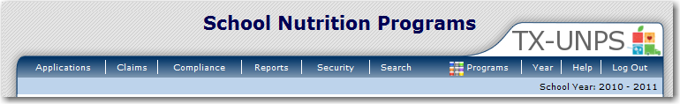

Step 2: Select “Claim – SSO”
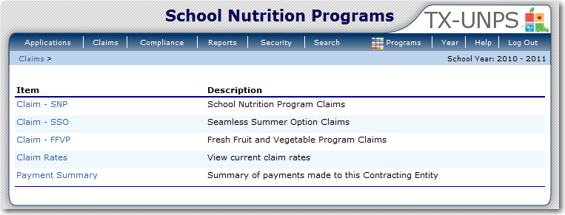

Step 3: On the SSO Claim Year Summary screen, select Claim Month for the file to be uploaded
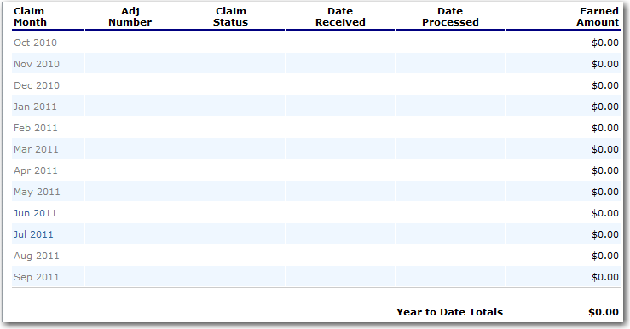

Step 4: On the SSO Claim Month Details screen, select the “Add Original Claim” button
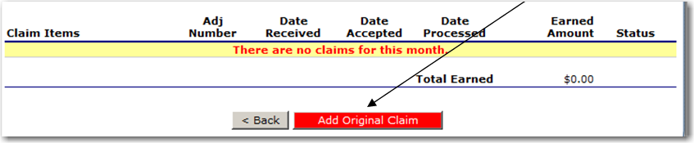
Step 5a: Select the “Upload Claim Data” button

Step 5b: Select the POS claim file to be uploaded (use the Browse button to locate the file)
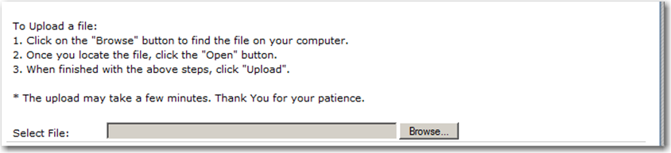

Step 5c: Select the “Upload” button
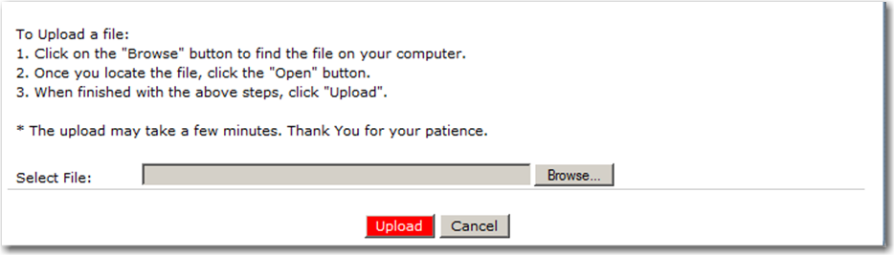

Appendix A

TX-UNPS

SNP Seamless Summer Point of Sale (POS) File Format Specifications

- Each row in the POS file is a site claim for a respective claim month; multiple sites (i.e., records) are included in a single POS file.
- Fields related to each meal type are grouped and identified as follows:
  - “SL” fields = National School Lunch Program
  - “SB” fields = School Breakfast Program (Regular)
  - “SN” fields = School Breakfast Program (Severe Need)
  - “SS” fields = Afterschool Care Program Snacks

Field Seq. | Position From | Position To | Description | Field Length | Field Type | Required Field? | Instructions
1 | 1 | 3 | Upload Form ID | 3 | N(3,0) | Y | Claim General Information  Insert value = 712 for every record
2 | 4 | 9 | Sequential Number | 6 | N(6,0) | Y | Claim General Information  Sequential Record Number (1, 2, 3, etc.)  The sequential number MUST be unique within a POS file
3 | 10 | 17 | Process Date | 8 | N(8,0) | N | Claim General Information  Date the Contracting Entity exported the data from their system  Format: MMDDYYYY  NOTE: This data is not stored or used within TX-UNPS; however, it may be useful to the Contracting Entity
4 | 18 | 81 | Contracting Entity Name | 64 | C(64) | Y | Claim General Information  Name of the Contracting Entity (as indicated within TX-UNPS)
5 | 82 | 86 | Contracting Entity ID | 5 | C(5) | Y | Claim General Information  Unique five digit Contracting Entity ID that was system generated by TX-UNPS; this MUST match the CE ID defined within TX-UNPS.  Zero fill from left (e.g. 01234)
6 | 87 | 150 | Site Name | 64 | C(64) | Y | Claim General Information  Name of the Site (as indicated within TX-UNPS).
7 | 151 | 154 | Site ID | 4 | C(4) | Y | Claim General Information  Unique four digit Site ID maintained within TX-UNPS; this MUST match the Site ID defined within TX-UNPS.  Zero fill from left (e.g., 0114)
8 | 155 | 156 | Claim Month | 2 | N(2,0) | Y | Claim General Information  The two-digit calendar month for which the claim is being submitted  Example: January = 01; February = 02, etc.
9 | 157 | 160 | Claim Year | 4 | N(4,0) | Y | Claim General Information  The four digit calendar year for which the claim is being submitted  Example: 2011
10 | 161 | 161 | For future use | 1 |  | N | Leave blank – TX-UNPS will use in future enhancements
11 | 162 | 168 | SL1 - Authorized Sites Participating | 7 | N(7,0) | N | If not claiming Lunch meals, leave blank
12 | 169 | 175 | SL2 - Enrollment | 7 | N(7,0) | N | If not claiming Lunch meals, leave blank
13 | 176 | 177 | SL3 - Number Operating Days | 2 | N(2,0) | N | If not claiming Lunch meals, leave blank
14 | 178 | 184 | SL4 - Free Lunches Served | 7 | N(7,0) | N | If not claiming Lunch meals, leave blank
15 | 185 | 191 | SL5 - Free Suppers Served | 7 | N(7,0) | N | If not claiming Lunch meals, leave blank
16 | 192 | 199 | Add SL6 | 8 |  |  | Leave blank – TX-UNPS will use in future enhancements
17 | 200 | 206 | SB1 - Authorized Sites Participating | 7 | N(7,0) | N | If not claiming Breakfast meals, leave blank
18 | 207 | 213 | SB2 - Enrollment | 7 | N(7,0) | N | If not claiming Breakfast meals, leave blank
19 | 214 | 215 | SB3 - Number Operating Days | 2 | N(2,0) | N | If not claiming Breakfast meals, leave blank
20 | 216 | 222 | SB4 - Free Breakfasts Served | 7 | N(7,0) | N | If not claiming Breakfast meals, leave blank
21 | 223 | 230 | Add SB5 | 8 |  |  | Leave blank – TX-UNPS will use in future enhancements
22 | 231 | 237 | SN1 - Authorized Sites Participating | 7 | N(7,0) | N | If not claiming Severe Need Breakfast meals, leave blank
23 | 238 | 244 | SN2 - Enrollment | 7 | N(7,0) | N | If not claiming Severe Need Breakfast meals, leave blank
24 | 245 | 246 | SN3 - Number Operating Days | 2 | N(2,0) | N | If not claiming Severe Need Breakfast meals, leave blank
25 | 247 | 253 | SN4 - Free Severe Need Breakfasts Served | 7 | N(7,0) | N | If not claiming Severe Need Breakfast meals, leave blank
26 | 254 | 261 | Add SN5 | 8 |  |  | Leave blank – TX-UNPS will use in future enhancements
27 | 262 | 268 | SS1 - Authorized Sites Participating | 7 | N(7,0) | N | If not claiming Afterschool Care Program snacks, leave blank
28 | 269 | 275 | SS2 - Enrollment | 7 | N(7,0) | N | If not claiming Afterschool Care Program snacks, leave blank
29 | 276 | 277 | SS3 - Number Operating Days | 2 | N(2,0) | N | If not claiming Afterschool Care Program snacks, leave blank
30 | 278 | 284 | SS4 - Free AM Snacks Served | 7 | N(7,0) | N | If not claiming Afterschool Care Program AM snacks, leave blank
31 | 285 | 291 | SS5 - Free PM Snacks Served | 7 | N(7,0) | N | If not claiming Afterschool Care Program PM snacks, leave blank
32 | 292 | 299 | Add SS6 | 8 |  |  | Leave blank – TX-UNPS will use in future enhancements

